SQL Notes LeetCode

1. 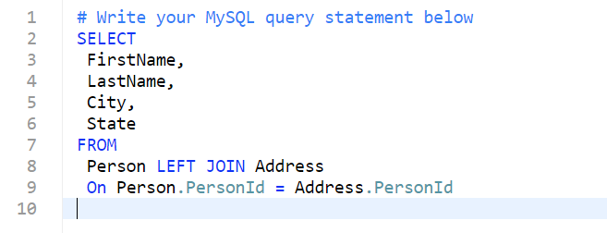Combie 2 tables: Use Left Join
2. 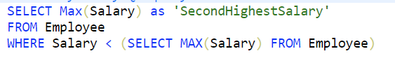Second Highest: Nested Select under WHERE
3. 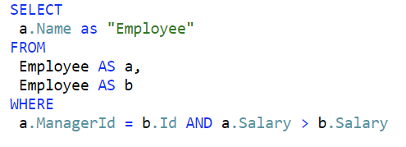Employee Earning More than their Managers: DOUBLE TABLE WHERE
4. 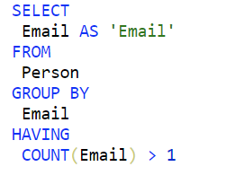Duplicate Emails: GROUP BY (ASEC) HAVING and COUNT
5. 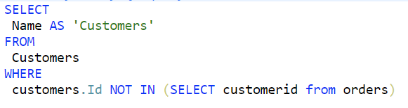Customers Who never Order – NOT IN
6. 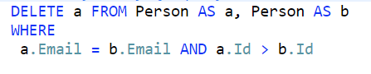Delete Duplicate Emails : DELETE, DOUBLE TABLE WHERE
7. 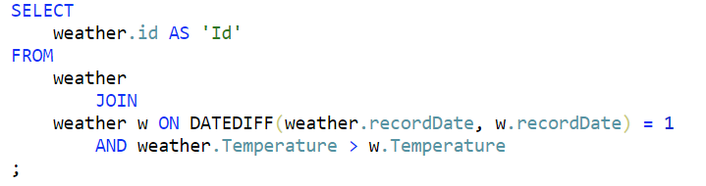Rising Temperature: DOUBLE TABLE ON DATEDIFF
8. 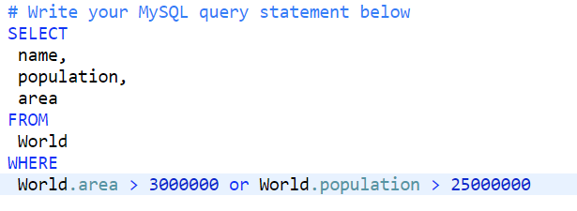Big Countries: WHERE OR
9. 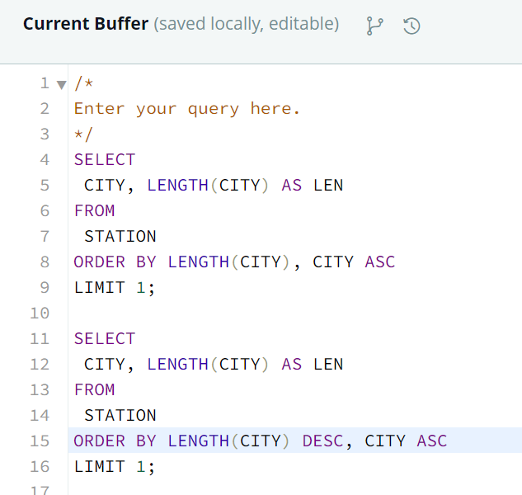Shortest and Longest City Names
10. CITY names starting with vowels : USE LIKE
11. 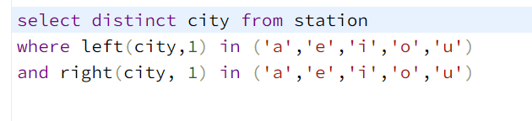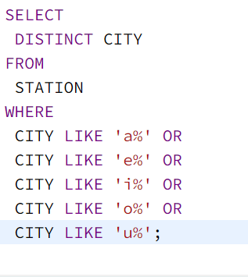CITY Names which has vowels as BOTH First and last characters.
12. 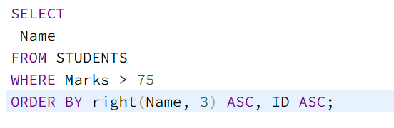HIGHER than 75 marks: Order by last 3 characters, if same, order by ascending ID.
13. 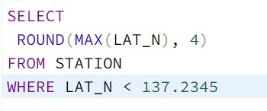Greatest LAT_N that is less than 137.2345 4 decimal places
14. 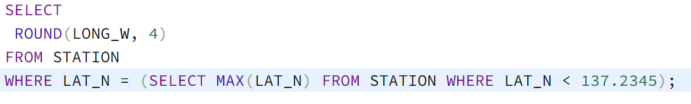Query the Western Longitude (LONG_W) for the largest Northern Latitude (LAT_N) in **STATION** that is less than 137.2345 : Nested sub-query
15. Manhattan Distance: P1 & P2
16. 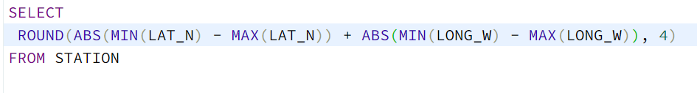Euclidean Distance : 2d P1 & P2
17. 